**­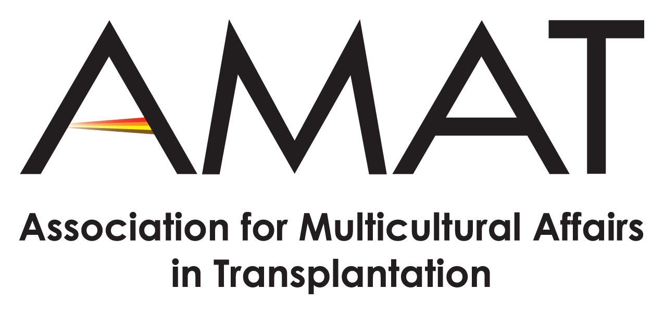 **

**Media Contacts:**

**Donate Life America**

Hilary Czarda

HCzarda@donatelife.net, 804-377-3584

**AMAT**

Tanise Love

[tlove@donatelifenc.org](mailto:tlove@donatelifenc.org), 317-413-3299

**2017 Donate Life ECHO Focuses on the Importance of Donation and Transplantation in Multicultural Communities**

***Video contest storytelling, Spanish language web registration and DLA National Partner Walgreens drive outreach of 2017 Donate Life ECHO***

**(Richmond, VA—June 27, 2017)** — Multicultural communities are disproportionately in need of lifesaving organ transplants – especially kidneys. Currently, 58 percent of the U.S. transplant waiting list is comprised of ethnically diverse patients. To address this need, Donate Life America (DLA) and the Association for Multicultural Affairs in Transplantation (AMAT) created Donate Life ECHO. Held each year in July, Donate Life ECHO is the national two-week outreach campaign, focused on the importance of donation and transplantation in multicultural communities. ECHO stands for Every Community Has Opportunity – the opportunity to save and heal lives.

“ECHO is about giving every community a voice in saving and healing lives, through organ, eye and tissue donation,” says Remonia Chapman, president of AMAT. “Diverse languages, different methods, yet one message – LIFE."

This year, Donate Life ECHO will be held July 9-22 and will include:

* **#HearMyStoryOf Video Contest:** Open to individuals and groups to create a 30-60 second video sharing their donation and transplantation story and Donate Life ECHO message. Video entries will use the hashtag #HearMyStoryOf, e.g., #HearMyStoryOf #Hope, #HearMyStoryOf #Waiting, #HearMyStoryOf #LIFE, to speak on a personal level about the importance of multicultural communities registering their decisions to be organ, eye and tissue donors. The video contest will be hosted on Facebook.com/DonateLife.
* **Walgreens efforts to help raise consumer awareness**: Throughout July, information about Donate Life ECHO will be featured on Walgreens health resource panels included with prescriptions filled at its retail and local specialty pharmacies nationwide. In addition, Walgreens will host donor registration drives at select Walgreens stores in a few markets across the country.
* **DoneVida.org**: Donate Life America is excited to launch a website that offers the online national registration opportunity and resources in Spanish. Signing up at DoneVida.org registers your donation decision in the National Donate Life Registry (RegisterMe.org).

United Network for Organ Sharing (UNOS) research reveals that, “successful transplantation is often enhanced by the matching of organs between members of the same ethnic and racial group.” Increasing educational efforts, outreach and registration opportunities are vital steps towards increasing the number of registered donors and lives saved in multicultural communities.

“Donate Life ECHO was started with the aim of giving voice to the experience of multicultural communities with donation and transplantation,” says Bobby Howard, DLA board member and past president of AMAT. “To increase our educational outreach efforts and donor registrations, voices and stories from these communities need to be heard.”

Donate Life ECHO resources are available in English and Spanish. Resources and more information about how to be a part of Donate Life ECHO are available at: [DonateLife.net/ECHO](https://www.donatelife.net/echo/) and [amat1.org/programs/ECHO](http://www.amat1.org/programs/echo/).

You can register your decision to be an organ, eye and tissue donor in the National Donate Life Registry at [RegisterMe.org](registerme.org), in the Medical ID Tab of your iPhone Health App or in Spanish at <DoneVida.org>.

*Data from Organ Procurement and Transplantation Network (OPTN) as of May 7, 2017.*

**###**

**About the Association of Multicultural Affairs in Transplantation (AMAT)**

AMAT was established in 1992 to address the increasing need for organ and tissue donors in the multicultural communities while simultaneously offering support, shared expertise and professional development opportunities for its members as they save and heal lives. AMAT is a self-sustaining, self-governed organization operating solely on voluntary contributions from individuals, corporations, and other affiliated organizations. For more information, visit: [www.AMAT1.org](http://www.AMAT1.org).

**About Donate Life America (DLA)**

Donate Life America is a 501(c) 3 nonprofit alliance of national organizations and Donate Life State Teams across the United States committed to increasing the number of donated organs, eyes and tissue available for transplant to save and heal lives. Donate Life America manages and promotes the national brand for donation, Donate Life℠; develops and executes effective multi-media donor education programs; motivates the American public to register now as organ, eye and tissue donors; manages the National Donate Life Registry, RegisterMe.org; and assists Donate Life State Teams and national partners in facilitating high-performing donor registration programs.